**Barrie Rugby Club**

**Mini Rugby Kit Sizing Guidelines**

BASIC MEASUREMENTS - RUGBY SHORTS

|  |  |  |  |  |  |  |  |  |  |  |
| --- | --- | --- | --- | --- | --- | --- | --- | --- | --- | --- |
| All-purpose rugby short with shorter inseam: Fabric shrinkage has been accounted for; Tolerance:+/- 1/2" | | | | | | | | | | |
|
|  | YXS | YS | YM | YL | YXL/AXS | AS | AM | AL | AXL | A2XL |
|
| Waist relaxed | 8 | 9 | 10 | 11 | 12 | 13 | 14 | 15 | 16 | 17 |
|
| Inseam | 4 3/4 | 5 | 5 3/8 | 5 5/8 | 6 | 6 3/8 | 6 3/4 | 7 1/4 | 7 1/2 | 8 |
|
| BODY WAIST CIRC. | 21"-23" | 23"-25" | 25"-27" | 27"-29" | 29"-31" | 31"-33" | 33"-35" | 35"-37" | 37"-39" | 39"-41" |
|
|

|  |  |  |  |  |  |  |  |  |  |  |
| --- | --- | --- | --- | --- | --- | --- | --- | --- | --- | --- |
|  | BASIC MEASUREMENTS - JERSEY | | | |  |  |  |  |  |  |
| (in Inches) |  | Youth |  |  |  | Adult |  |  |  |  |
|  | S | M | L | XS | S | M | L | XL | 2XL | 3XL |
| Front Body Length | 23" | 24.5" | 26" |  |  |  |  |  |  |  |
| Chest Width | 17" | 18" | 19" | 20" | 21" | 22" | 23" | 24" | 25" | 26" |
| Chest Full | 34" | 36" | 38" | 40" | 42" | 44" | 46" | 48" | 50" | 52" |

**How to order your rugby kit**

Immediately after you have paid your registration fee through the online registration website please complete the Kit Ordering Form below and email it to our Kit Manager Travis MacIver at equipment.order@barrierugbyclub.com . When ordering your child’s kit please consider ordering the shirt a size larger than required so you get at least two seasons play out of it. In order to get your kit customised with your child’s name you need to register and order the kit before April 15, 2017 or we cannot guarantee the shirt will have your child’s name on the back. Please note socks are provided as part of the kit.

**Barrie Rugby Club mini rugby kit policy**

Every child’s initial registration fee with Barrie Rugby Club minis at any age group up to and including our Under 12 program includes a free shirt, shorts and socks. After this initial free kit is provided parents will be required to pay for any replacement kit at their own expense, this can be ordered and paid for through our Kit Manager. The playing kit we provide is highly durable so you should be able to get two seasons play from it. As of 2016 a replacement shirt and shorts currently costs approximately $60 but this may be subject to change. Socks are provided as part of the kit.

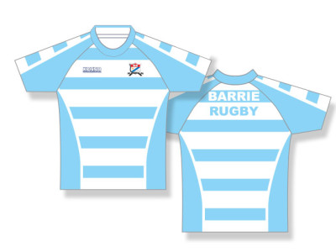

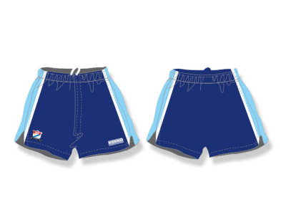

**PLEASE RETURN JUST THIS PAGE COMPLETELY FILLED IN**

**Barrie Rugby Club Kit Order Form**

Please circle shirt and short size required

|  |  |  |  |  |  |  |  |  |  |  |
| --- | --- | --- | --- | --- | --- | --- | --- | --- | --- | --- |
| RUGBY SHIRTS | YS | YM | YL | AXS | AS | AM | AL | AXL | A2XL | A3XL |
|  |  |  |  |  |  |  |  |  |  |  |
| RUGBY SHORTS | YXS | YS | YM | YL | YXL | AS | AM | AL | AXL | A2XL |
|  |  |  |  |  |  |  |  |  |  |  |

PARENT NAME __________________________________ EMAIL ___________________________________

SIGNATURE __________________________________ PHONE _________________________________

LAST NAME ON JERSEY ____________________________ AGE GROUP ____________________________

PLAYER’S FIRST NAME ________________________________ MALE or FEMALE?

HAS YOUR CHILD PLAYED FOR BARRIE RUGBY CLUB BEFORE? YES or NO

PLEASE COMPLETE THIS FORM AS SOON AS YOU HAVE PAID TO REGISTER YOUR CHILD ONLINE AND EMAIL IT TO OUR KIT MANAGER TRAVIS MACIVER AT equipment.order@barrierugbyclub.com. IN ORDER TO GET YOUR KID CUSTOMISED WITH YOUR CHILD’S NAME YOU NEED TO REGISTER AND ORDER YOUR KIT BEFORE APRIL 15, 2017 OR WE CANNOT GUARANTEE WE CAN GET YOUR CHILD’S NAME ON THE BACK OF THE SHIRT.